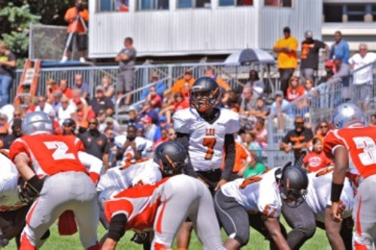
LEO HIGH SCHOOL 2017 VARSITY FOOTBALL SCHEDULE
Friday, August 25th against Lane Tech (Home @ Solider Field) 7pm
Friday, September 1st @ Niles North (Away) 7:30 pm
Friday, September 8th, Hope Academy (Away) 7:30 pm
Friday, September 15th Fenwick (Away) 7:30 pm
Friday, September 22nd HOMECOMING Bishop Mc
(Home @ KROC CENTER) 7:30 pm
Friday, September 29th St. Laurence (Home @ Bro Rice) 7:30 pm
Saturday, October 7th Loyola (Away) 1:00 pm
Friday, October 13th St. Joseph (Away) 7:30 pm
Friday, October 20th DePaul Prep SENIOR NIGHT (Home @ KROC CENTER)

