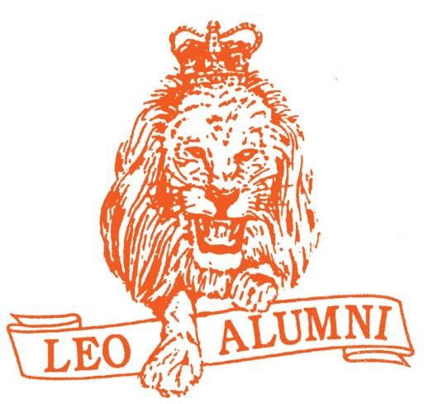
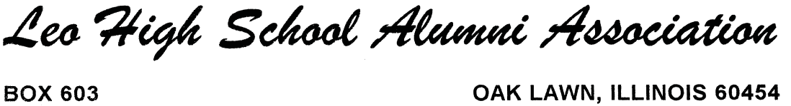
LEO ALUMNI ASSOCIATION …..Annual Golf Outing…..
(Friends of Leo are Welcome)
GLENEAGLES COUNTRY CLUB
“Best Ball Scramble”
WEDNESDAY, AUGUST 1st, 2018, 9:00 AM tee time

Over 300 Leo Alumni in attendance at Golf Outing
Over 600 Leo Alumni attend Annual Banquet
Leo Alumni represents groups from all over the Chicagoland Area
Loyal Sponsors Needed
Hole in One Sponsor $750
Long Drive Sponsor $500
Chip Shot Sponsor $300
One Putt Sponsor $200
Sign on a Hole Sponsor $100

Donations Needed
- Every type of gift can be added to baskets or as prize give-a-ways
- Baskets, Bottles of Booze, Sports items of any kind
- Golf Equipment, Event Tickets, Restaurant Gift Cards
- Monetary donations always accepted

Contact: Scott Fulwiler 82 Iliad Drive, Tinley Park, 60477 708-429-1896 slfulwiler@comcast.net

All proceeds go directly to the LEO ALUMNI ASSOCATION for the Benefit of Leo High School School
State tax exempt number available on request.

OFFICERS
Thomas W. Lynch '73
President
John G. Gardner '75
Vice President
Larry Lynch '75
Vice President
Daniel K. Stecich '75
Vice President
Robert A. Cheval '74
Treasurer
Daniel M. Earner '82
Secretary
David F. Hannah '85
Public Relations Chairman Brian M. Earner ‘93
Events Coordinator Ginger Ling
Alumni Administrative Assistant

BOARD OF DIRECTORS
Gene Earner '50
Chairman Larry Bahnaman '60
Terrance L. Bates '86
John J. Benedek '67
Dennis Barista ‘74
Noah Cannon '95
James E. Corbett '52
Brian M. Earner '93
Jack C. Farnan '63
James M. Farrell '61
Richard L. Furlong '59
Scott Fulwiler ‘74
Donald F. Hogan '45
Michael Holmes '76
Mark Lee '85
John G. Linehan '77
Keith Martin '93
Frank M. McDermott '57
Daniel B. McGrath '68
Shelvin Payne’96
Bernard J. Pepping '57
Shaka Rawls '93 Jerry Schmitt '58
Robert F. Sigel '53
Arthur F. Skinner '48
Gerald L. Tourville '48
Andre Weathers '02
Antrywan Williams '89

